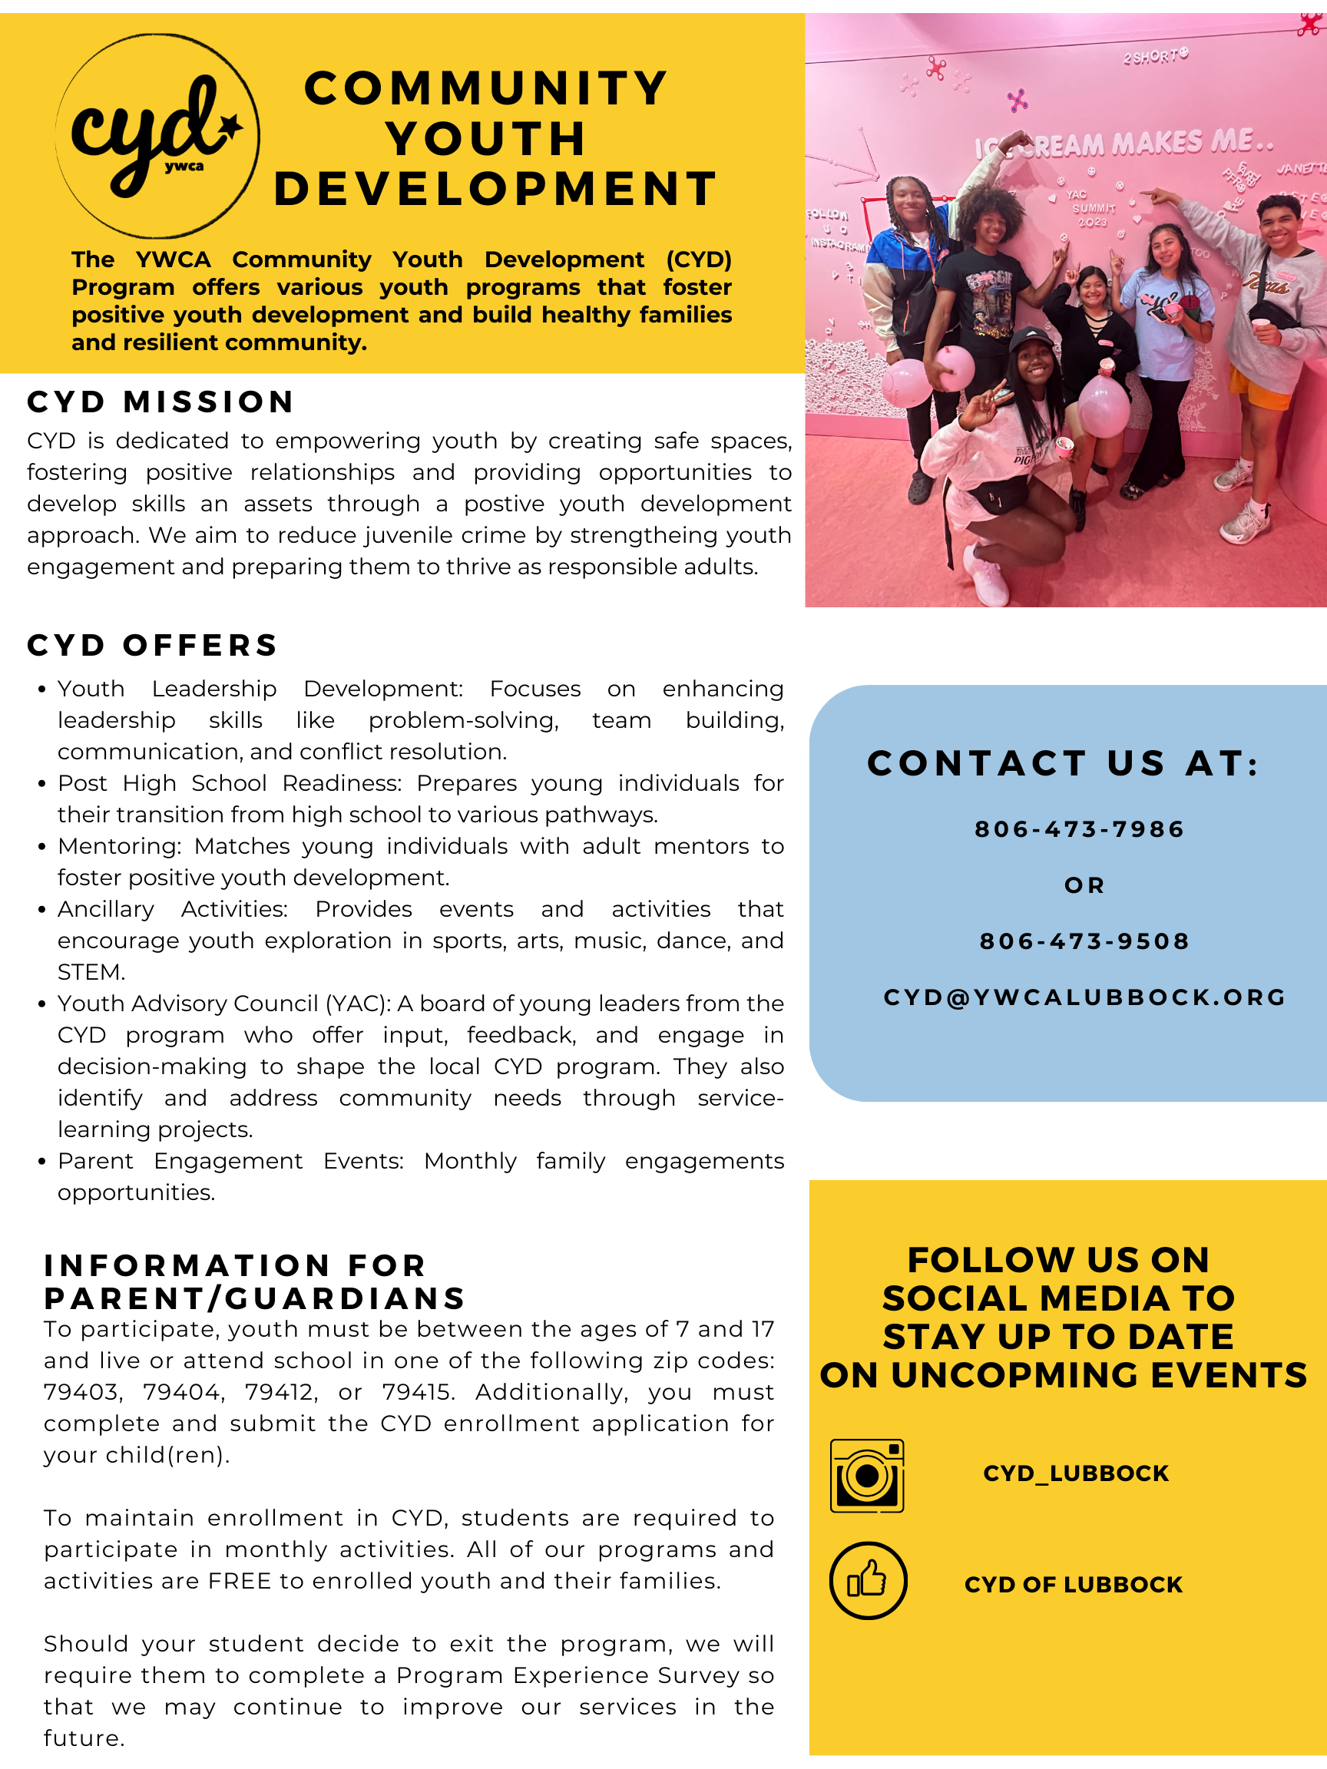

Family Support Services (FSS)
PARTICIPANT ENROLLMENT FORM – YOUTH & FAMILY PROGRAMS

Program: Community Youth Development (CYD)
*Agency ID/Contract No.  24816819 | Subcontractor  N/A |  |  | *Workflow  CYD |  | *Enrollment ID No.
Planned Service Frequency  - Less than 1x Month  - 1x Month  - 2x Month  - More than 2x Month |  | *Enrollment Start Date |  |  | *Service Start Date
Staff Assigned to Family (Site Coordinator) |  | *Name of Person Completing Intake |  |  | *Data Entry Staff Name and Data Entry Date
*AUTHORIZATION FOR SERVICE
I have been provided information on the referenced Family Support Services Program and wish to receive services. I understand that data on my child/youth/family will be collected, maintained, and entered into a secure database. The information will be utilized to track services for evaluation purposes and to ensure quality services are being provided. I hereby authorize my child/youth/family to participate in the program.
*Printed Name of Parent or Guardian:
*Signature of Parent or Guardian:
*Date Signed (MM/DD/YYYY):
YWCA of Lubbock Media Release
Yes, I hereby grant permission for my child to be photographed at this YWCA of Lubbock program. I understand that these photographs may be used in promotional materials, both online and in print. I agree that this form will remain in effect during the term(s) of my child’s involvement with the YWCA of Lubbock.

No, I do not grant permission for my child to be photographed at this YWCA of Lubbock program.

YWCA of Lubbock Transportation Release
Yes, I hereby grant permission for the YWCA of Lubbock to transport my child on field trips and from school for after-school and summer programming.

No, I do not grant permission for my child to be provided transportation on field trips and from school for after-school and summer programming.

Index Child/Youth information
*First Name: |  | Middle Name:
*Last Name: |  | Suffix: II III IV JR SR
*Date of Birth: |  | *Sex: Male Female
*Hispanic Origin (select only one):
Hispanic Non-Hispanic Unable To Determine
*Race (select all that apply):  - American Indian/Alaska Native  - Unable To Determine | - Asian  - Declined to Indicate |  |  | - Black  - White |  | - Native Hawaiian/Pacific Islander
INDEX CHILD/YOUTH - PRIMARY ADDRESS
*Address: |  | *City: Lubbock
*State: Texas |  | *Zip Code: |  |  | *County: Lubbock

INDEX CHILD/YOuth - OTHER INFORMATION
*Disability Status: Yes No Not Assessed
Previous Juvenile Probation/TJJD Involvement:
Yes No
If yes, when was youth involved in Juvenile Probation:(MM/DD/YYYY) ___/____/______

Students Grade at Time of Enrollment: ______________ |  |  | Students School at Time of Enrollment: __________________

PRIMARY PARTICIPATING CAREGIVER INFORMATION
*First Name: |  |  | Middle Name:
*Last Name: |  |  | Suffix: II III IV JR SR
*Date of Birth: |  |  | *Sex: Male Female
*Primary Phone: |  |  | *Primary Email:
*Hispanic Origin (select only one):
Hispanic Non-Hispanic Unable To Determine
*Relationship to Index Child/Youth:  - Parent  - Foster Parent  - Stepparent  - Grandparent |  | - Aunt/Uncle  - Cousin  - Sibling  - Caregiver’s Partner |  |  | - Fictive Kin  - Unrelated
*Race (select all that apply):  - American Indian/Alaska Native  - Unable To Determine | - Asian  - Declined to Indicate |  |  | - Black  - White |  | - Native Hawaiian/Pacific Islander
PRIMARY PARTICIPATING CAREGIVER – OTHER INFORMATION
*Disability Status: Yes No Not Assessed
*Military Status:  No Military Service  Not Indicated  Active Duty  Active Reserve | National Guard Inactive Reserve  Retired  Veteran (discharge other than dishonorable)  Discharged – Dishonorable
Important Information for Former Female Military Service Members:
If you are an adult woman who served in the military, you may be entitled to additional services. Please visit the Texas Veterans Portal (veterans.portal.texas.gov) and TVC Women Veterans Program website (tvc.texas.gov/women).

PRIMARY PARTICIPATING CAREGIVER - PRIMARY ADDRESS
Use if different from Index Child/Youth Primary Address
*Address: | *City: Lubbock
*State: Texas | *Zip Code: | *County: Lubbock

*PRIORITY CHARACTERISTICS
Check “Yes” for all priority characteristics that are known at the time of enrollment. Check “No” for those that do not apply and/or are not known at the time of enrollment. When entering this information in PEIRS, you will only enter the “Yes” answers.

CYD program requires two for eligibility.
Priority Characteristics | Yes | No
Behavioral Concern
Current or Former Military Connection
Current or Past Child Maltreatment or Child Welfare Involvement
Current or Past Criminal Justice Involvement - Youth
Current or Past Domestic or Interpersonal Violence
Current or Past Substance Use or Alcohol Use – Youth
Developmental Delay or Disability - Caregiver
Developmental Delay or Disability - Index Child/Youth
High Stress Level
Homeless, runaway or housing instability
Household contains an enrollee who is Pregnant and under 21
Household has a child with developmental delays or disabilities
Household has a history of alcohol abuse or a need for alcohol abuse treatment
Kinship Support
Low-Income Household
Mental Health Concern - Caregiver
Mental Health Concern - Index Child/Youth
Parenting/Caregiver Skills Concern
School Engagement Concern
Social Support Concern
Someone in the household has low student achievement or has a child with low student achievement
.

*Primary Language Spoken in the Home:

English Spanish Vietnamese Chinese Other__________ Not Assessed
*Referred By:   Self-Referral (Parent)   Self-Referral (Youth)   Friend/Relative   School, daycare or other education provider   Healthcare provider   Clergy/Church   Child Protective Services   Law Enforcement   Juvenile Justice System   Texas Youth/Runaway Hotline |  |  211 or other hotline   Prior Participant   Family Connects   Other Community Agency   Other   Early Childhood Intervention (ECI)   Pregnancy Resource Centers   Texas Thriving Families   Women, Infants and Children (WIC)
*Eligible for CYD by:  *Only check one box | Zip Code: _________________  School Name: ______________  Eligible on 30% Rule  list 30% School_______________________ |  | Other  (justification)_______________________________  ________________________________________  _________________________________________________

